**AER210 Microfluidics Lab Report**

**Tinglin Duan, Student Number 1001093899, lab conducted on Oct 7, 2015**

**Introduction**

Microfluids are observed tending to change their velocities and directions as the width and the direction of the channel changes. This experiment is performed to test and demonstrate these behaviors at a microscope. The results of the experiment would have benefits on the understanding of practical use in fields of blood flow, modern DNA sequencing and biological microchip applications.

The apparatus used are an Olympus Inverted Microscope CK 40 with UV Power Supply Unit, a microfluidics chip in a Petri dish, a suspension of fluorescent diluted beads, a 10ml syringe, thin tubing, a clamp stand and a hemacytometer.

**Experimental Procedures and Results**

The procedure from the laboratory manual [1] is followed. And there is no significant deviation from the procedures described.

A hemacytometer is adopted as a scale to measure the lengths at micro scales.

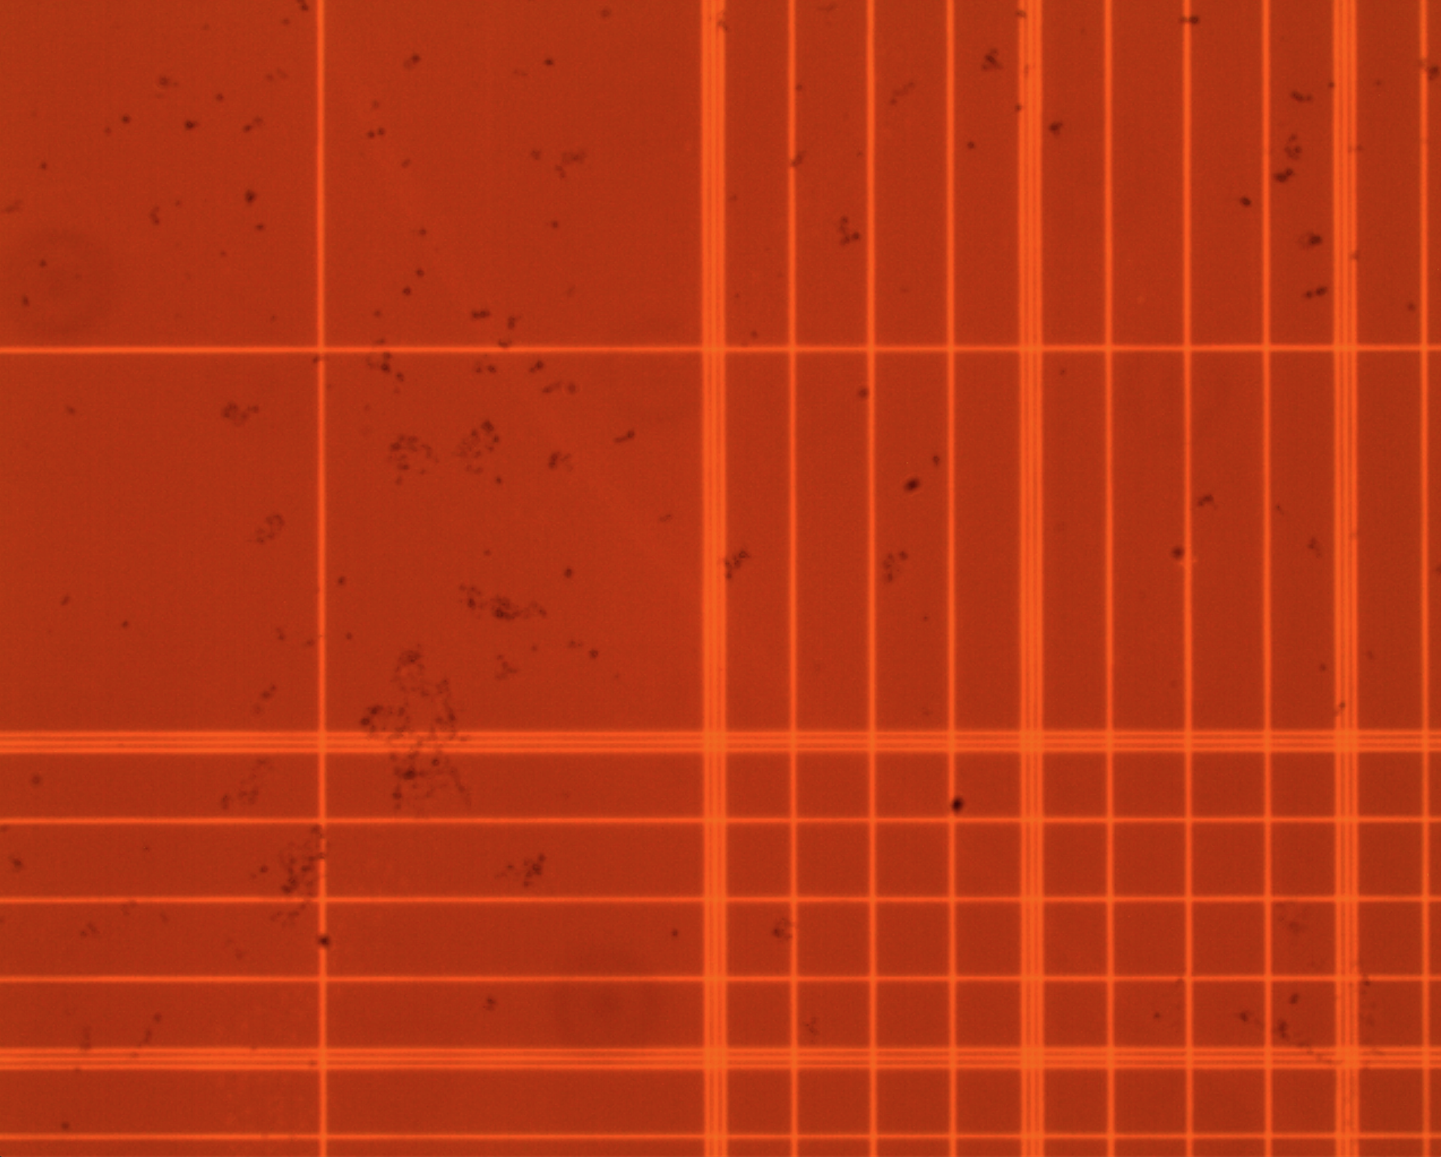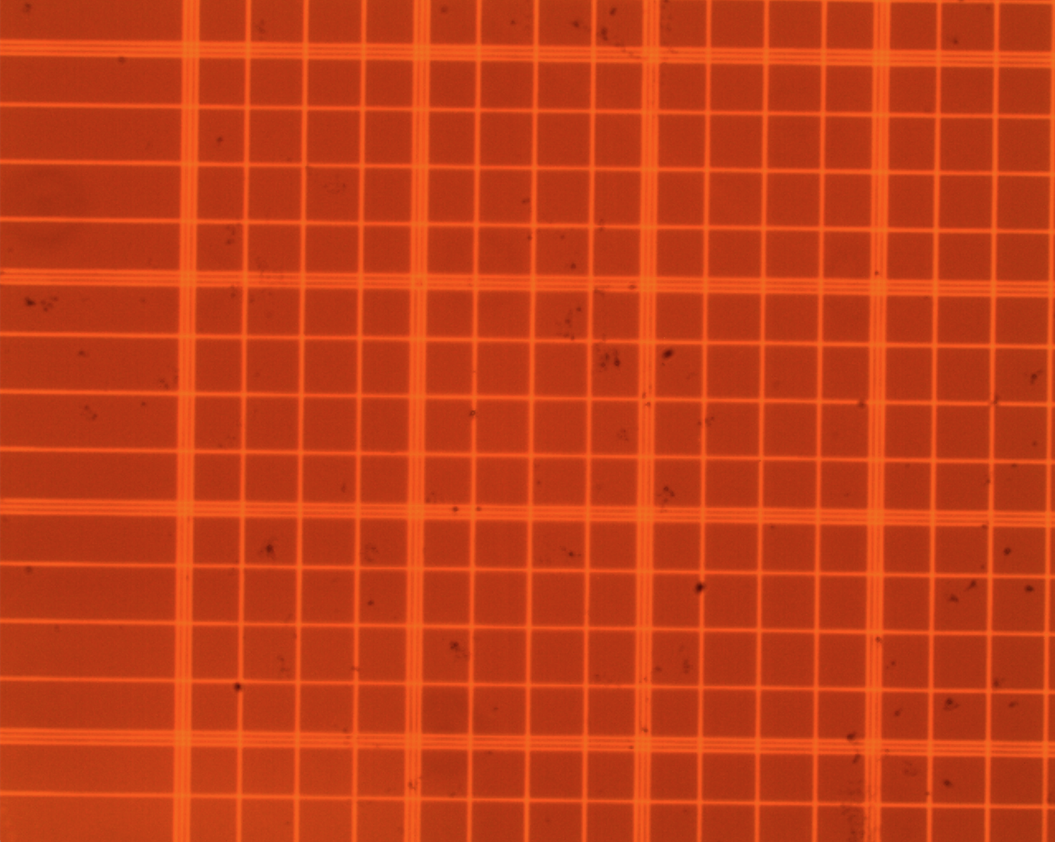

Figure 1 x100 magnification of hemacytometer

A straight channel, a nozzle channel and a sharp angle channel are used during the performance of the experiment. In each channel the motion of the fluid is observed and the photos taken are listed below, where the red lines on sides are the edges of the channels and the bright red dots or lines inside the channels are the micro beads observed.

**1. Straight Channel**

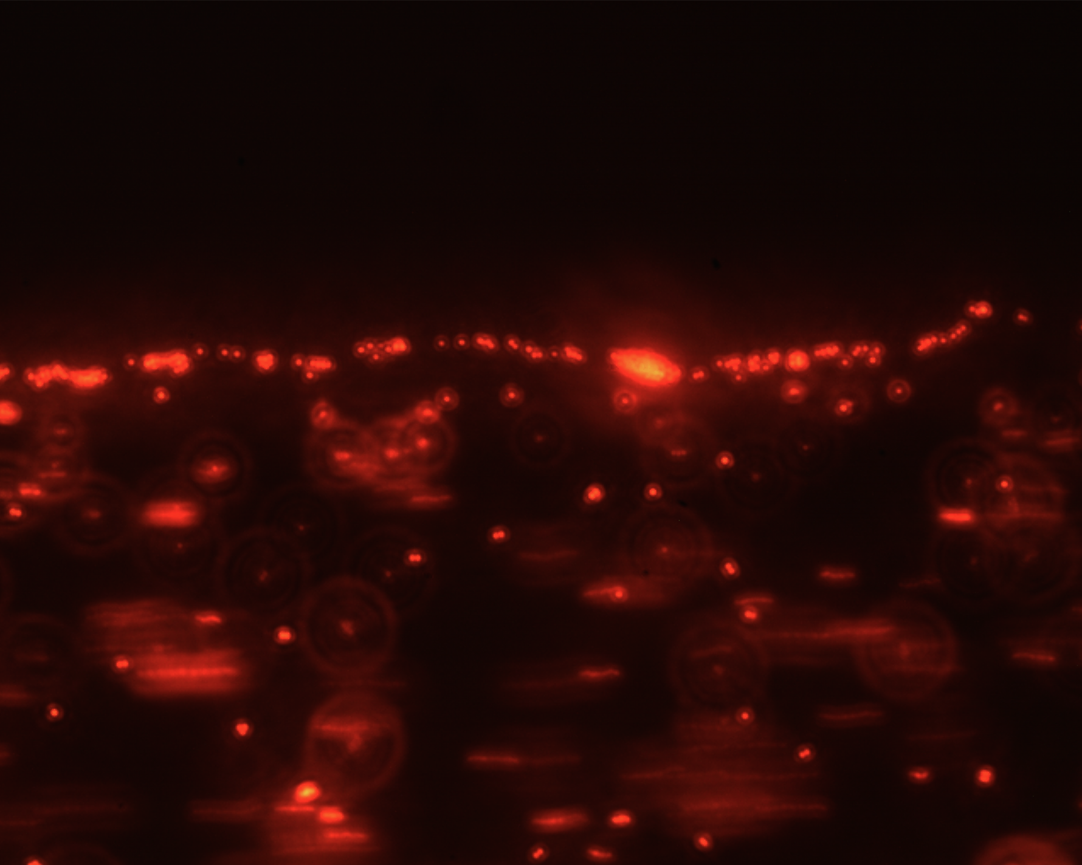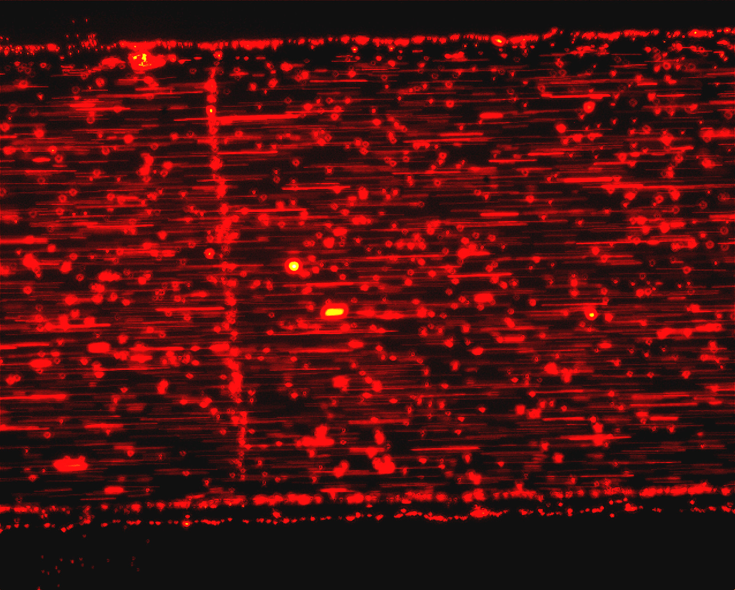Firstly the motion in a straight channel is observed. As there is no significant change in directions or width, the velocity of a certain beam tends to maintain the same, while the beads in the center tend to have higher velocities than those on the sides. The imperfection of the channel edges is also observed in this section.

Figure 2(b) x400 magnification of the straight channel (edge imperfection)

Figure 2(a) x100 magnification of the straight channel

**2. Nozzle Channel**

In the case of a nozzle channel, it is observed that when there is a gradual decrease in the width of the channel, the velocity of a certain bead gradually increases, whereas when the width gradually becomes larger the velocity would slightly decrease.

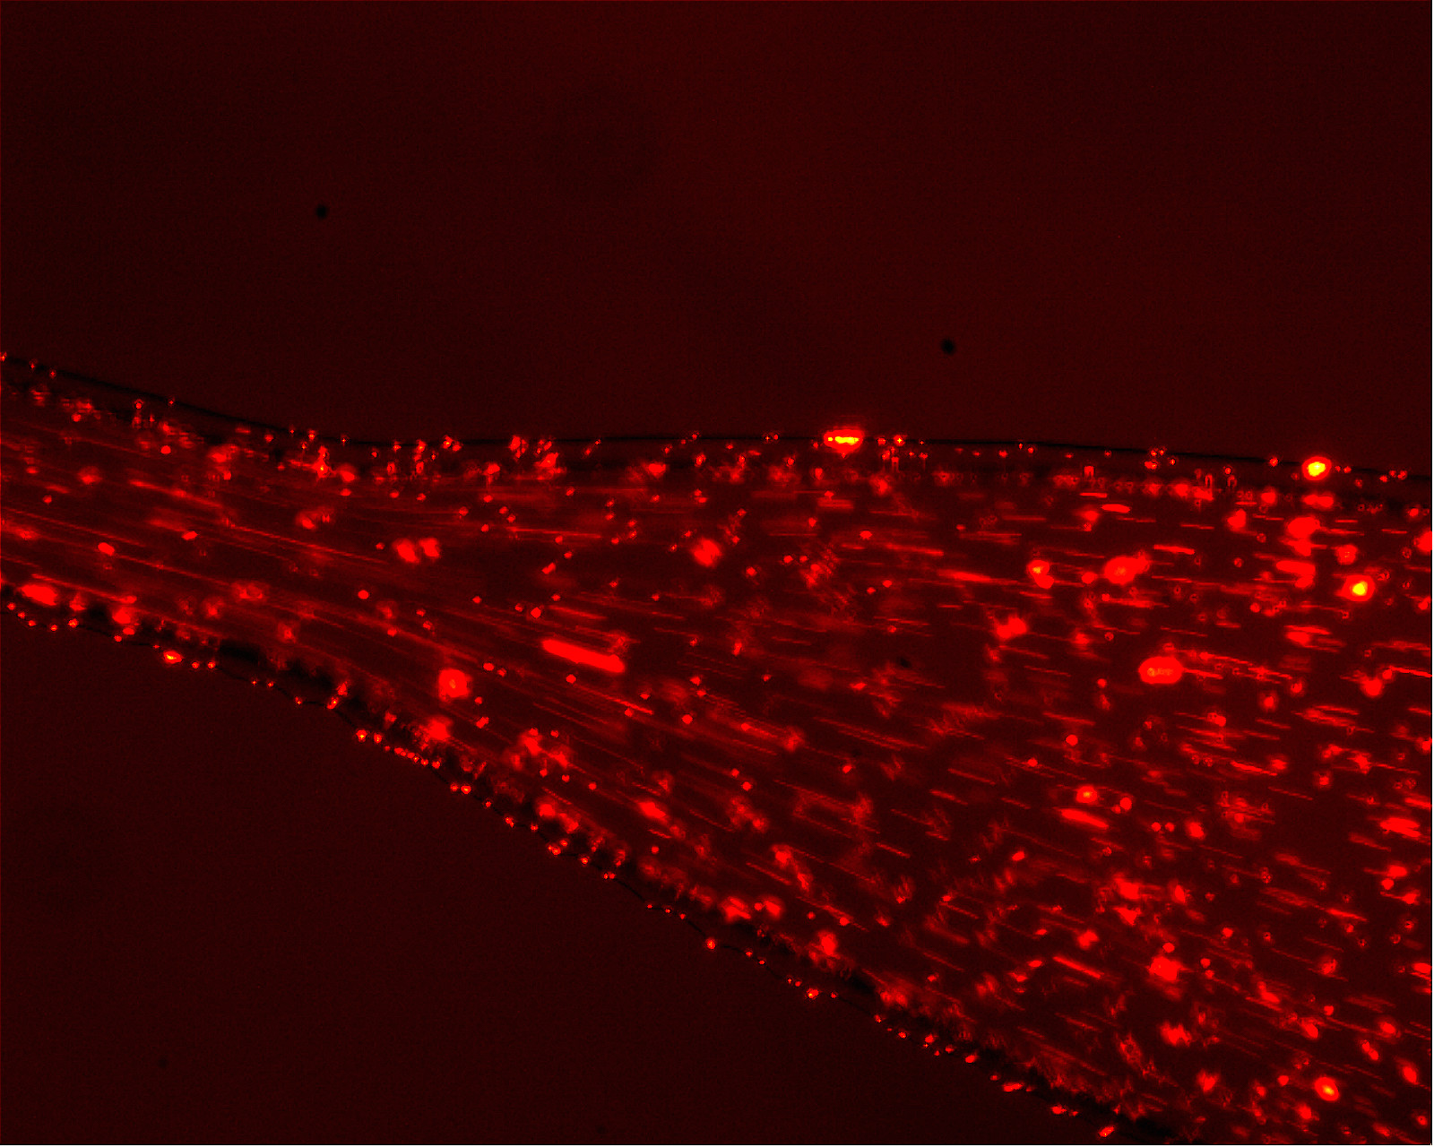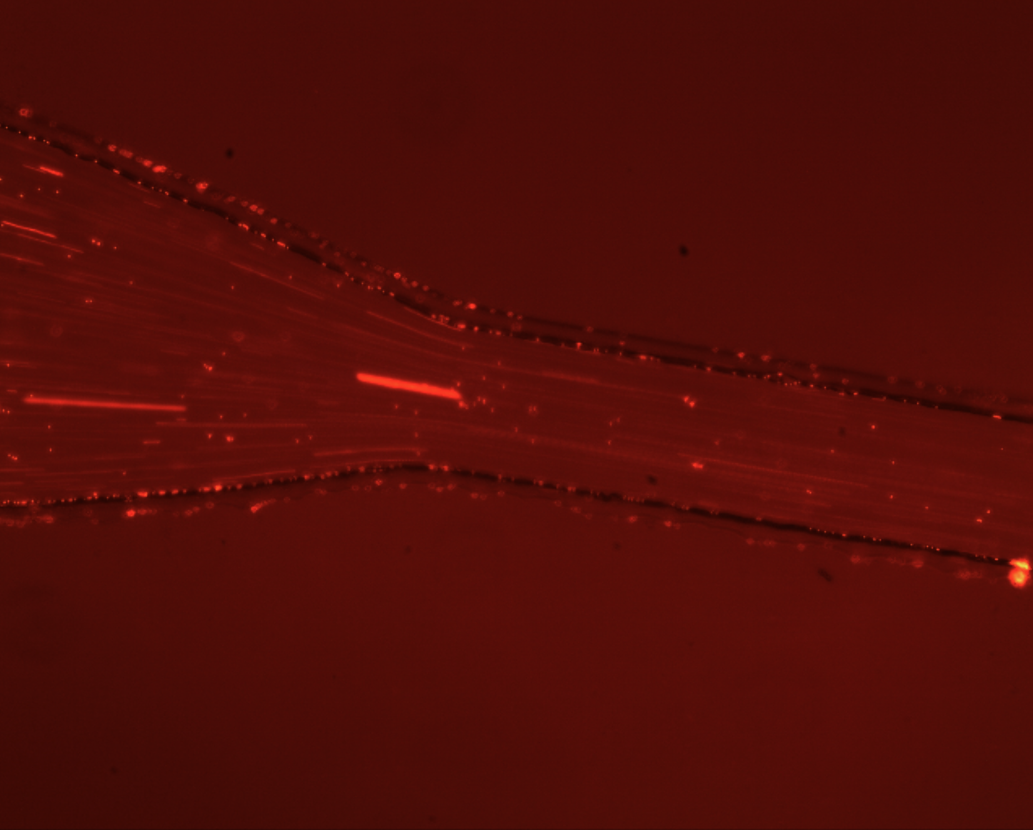

Figure 3(b) x100 magnification of the nozzle channel (width increasing)

Figure 3(a) x100 magnification of the nozzle channel (width decreasing)

**3. Sharp Angel Channel**

When the fluid is forced to go through a sharp angle channel, its velocity is observed to decrease.

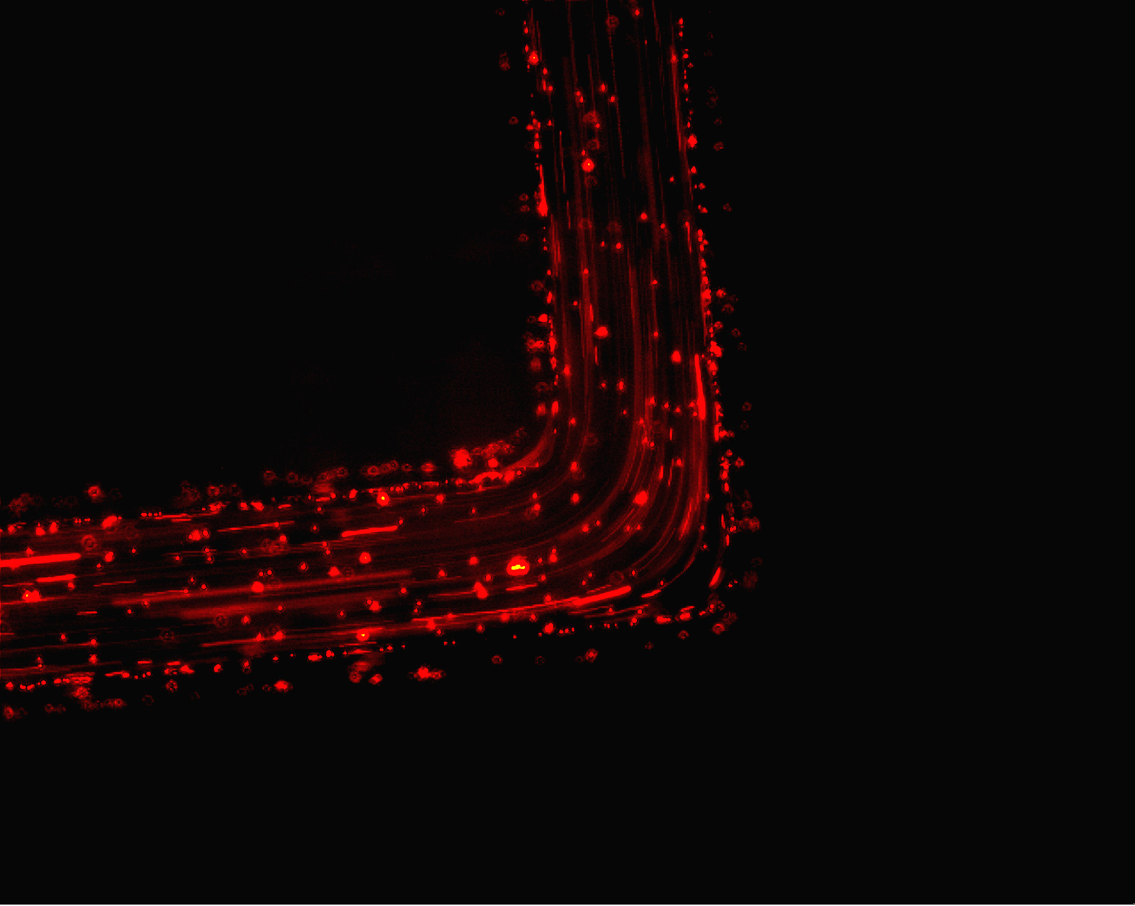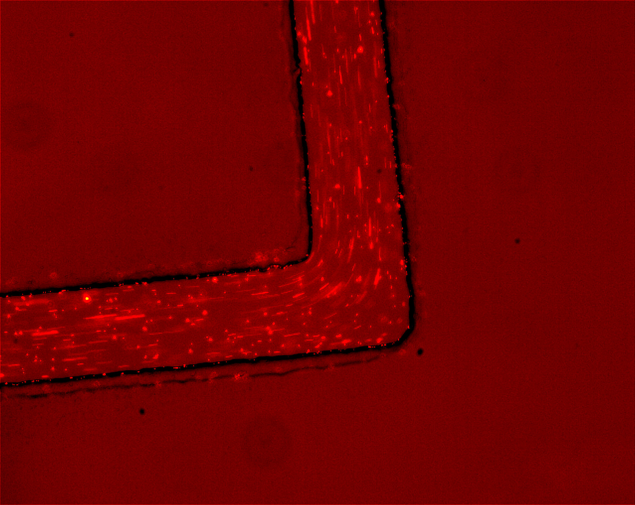

Figure 4(a) x100 magnification of the sharp angle channel

Figure 4(b) x100 magnification of the sharp angle channel

**Error Analysis**

The error in calculating the speed of the bead mainly comes from the reading error of using a hemacytometer. For example, at the x100 magnification of the hemacytometer, a reading error of ±0.005mm shall be taken into account (1/10 of the smallest scale). Moreover, there is also a ±0.1ms uncertainty of the exposure time, which contributes to the total uncertainty as well.

Use the formula to calculate the uncertainty in the velocity:

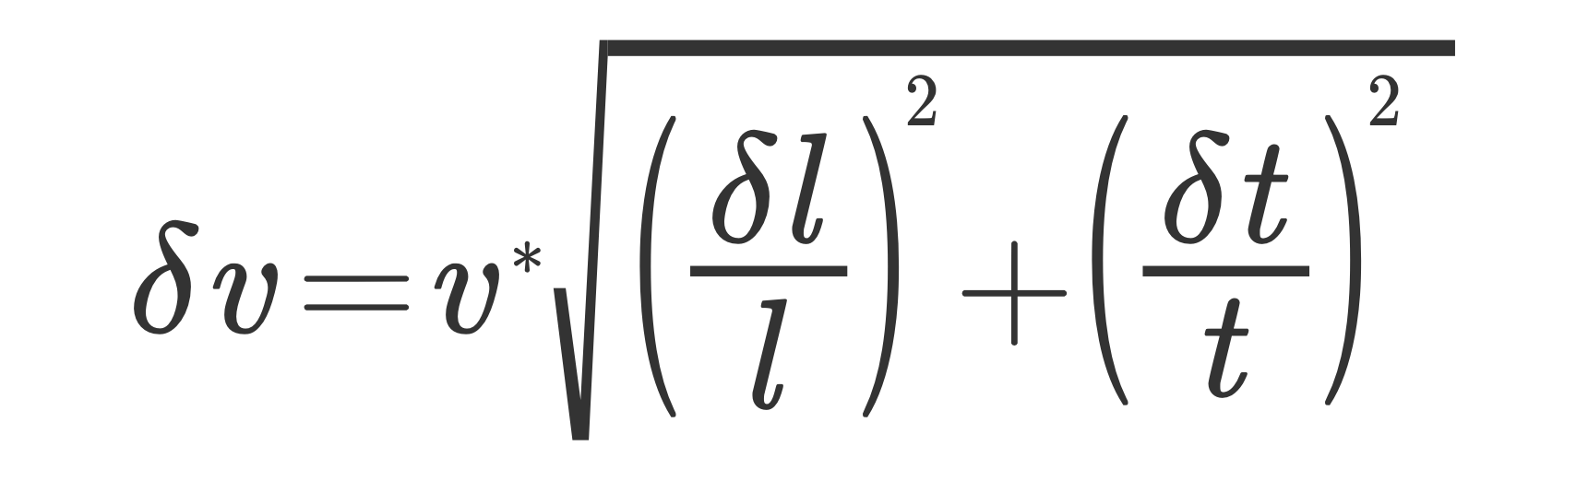

where v is velocity, l is the length measured, t is the exposure time of the camera, and δv, δl and δt are their respective errors.

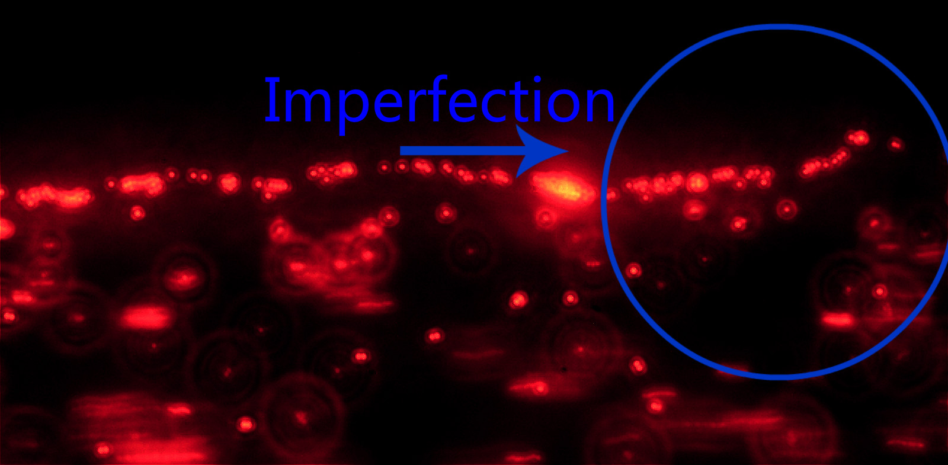

Figure 5 x400 magnification of the edge imperfection

Imperfection of the channel

During the experiment, channel imperfections are observed under the x400 magnification.

Although the imperfection is rather small (the channels are relatively “smooth” under x100 magnification), the imperfection would cause additional friction to the motions of the fluid on either side, which leads to possible anomalous behaviors. These imperfections would also contribute to the uncertainties.

**Discussion**

1. **Straight Channels**

|  |  |  |  |
| --- | --- | --- | --- |
| Bead | Exposure Time (ms) | Bead Length (mm) | Velocity (mm/s) |
| 1 | 500 ± 0.1 | 0.37 ± 0.005 | 0.74 ± 0.01 |
| 2 | 500 ± 0.1 | 0.36 ± 0.005 | 0.72 ± 0.01 |
| 3 | 500 ± 0.1 | 0.38 ± 0.005 | 0.76 ± 0.01 |
| 4 | 500 ± 0.1 | 0.13 ± 0.005 | 0.26 ± 0.04 |
| 5 | 500 ± 0.1 | 0.14 ± 0.005 | 0.28 ± 0.04 |
| 6 | 500 ± 0.1 | 0.21 ± 0.005 | 0.42 ± 0.02 |

Table 1 The results of the Straight Channel

Note: The first three beads are in the center and the last three are at the edges.

As there is least friction impact in the center of the straight channel, the maximum velocity is expected to be found there while the largest velocity difference shall be observed between the beads in the center and the beads at the edges. As is shown in **Table 1**, take bead 3 and 4 as examples, the bead in the center has a velocity of 0.76 ± 0.01 mm/s, and the bead at the edge has a velocity of 0.26 ± 0.04 mm/s, which makes a 65.8% ± 4.90% difference.

During the performance of the experiment, a laminar flow is observed as indicated by the straight beads shown in the camera. To find the velocity profile of the fluid, simply scale the length of the beads onto the hemacytometer and divide the resulted length by the exposure time. The calculated results are also listed in **Table 1**.

In order to manipulate the velocity, the height of the syringe could be adjusted to change the gravitational potential energy of the fluid. It is observed that the higher the syringe is placed the higher the velocity is.

1. **Channels of Different Size**

1. **The width increases**

|  |  |  |  |
| --- | --- | --- | --- |
| Bead | Exposure Time (ms) | Bead Length (mm) | Velocity (mm/s) |
| 1 | 342 ± 0.1 | 0.50 ± 0.005 | 1.46 ± 0.01 |
| 2 | 342 ± 0.1 | 0.87 ± 0.005 | 2.54 ± 0.01 |
| 3 | 342 ± 0.1 | 0.96 ± 0.005 | 2.81 ± 0.01 |
| 4 | 342 ± 0.1 | 0.24 ± 0.005 | 0.70 ± 0.02 |
| 5 | 342 ± 0.1 | 0.47 ± 0.005 | 1.37 ± 0.01 |
| 6 | 342 ± 0.1 | 0.51 ± 0.005 | 1.49 ± 0.01 |

Table 2 The results of the Nozzle Channel (width increasing)

Note: 1, 2 and 3 are the beads before going through the nozzle while 4, 5 and 6 are the same relative beads after going through the nozzle.

1. **The width decreases**

|  |  |  |  |
| --- | --- | --- | --- |
| Bead | Exposure Time (ms) | Bead Length (mm) | Velocity (mm/s) |
| 1 | 65 ± 0.1 | 0.26 ± 0.005 | 4.00 ± 0.02 |
| 2 | 65 ± 0.1 | 0.20 ± 0.005 | 3.08 ± 0.03 |
| 3 | 65 ± 0.1 | 0.21 ± 0.005 | 3.23 ± 0.02 |
| 4 | 65 ± 0.1 | 0.57 ± 0.005 | 8.77 ± 0.01 |
| 5 | 65 ± 0.1 | 0.46 ± 0.005 | 7.08 ± 0.01 |
| 6 | 65 ± 0.1 | 0.45 ± 0.005 | 6.92 ± 0.01 |

Table 3 The results of the Nozzle Channel (width decreasing)

Note: 1, 2 and 3 are the beads before going through the nozzle while 4, 5 and 6 are the same relative beads after going through the nozzle.

When the width of the channel decreases, the velocity of the beads increases; and when the width of the channel increases, the velocity of the beads decreases.

In **Table 2A** and **2B** the assumption is proved in practice. A certain bead is observed before and after passing through the nozzle and during each occasion its velocity is calculated. Take the bead 3 and 6 (same bead) in **Table 2A** as an example, its velocity before going through the nozzle is 2.81 ± 0.01 mm/s while the velocity after passing is 1.49 ± 0.01 mm/s, which makes a 47.0% ± 4.65% decrease.

An abrupt transition is expected to cause the fluid to change more quickly than a gradual one.

Same as the precious result, the gravity head manipulates the velocity of the fluid, the higher the syringe is placed, the higher the velocity goes.

1. **Bends in Channels**

|  |  |  |  |
| --- | --- | --- | --- |
| Bead | Exposure Time (ms) | Bead Length (mm) | Velocity (mm/s) |
| 1 | 432 ± 0.1 | 0.54 ± 0.005 | 1.25 ± 0.01 |
| 2 | 432 ± 0.1 | 0.58 ± 0.005 | 1.34 ± 0.01 |
| 3 | 432 ± 0.1 | 0.46 ± 0.005 | 1.06 ± 0.01 |
| 4 | 432 ± 0.1 | 0.40 ± 0.005 | 0.93 ± 0.01 |
| 5 | 432 ± 0.1 | 0.41 ± 0.005 | 0.95 ± 0.01 |
| 6 | 432 ± 0.1 | 0.42 ± 0.005 | 0.97 ± 0.01 |

Table 4 The results of the Sharp Angle Channel

Note: 1, 2 and 3 are the beads before going through the sharp angle while 4, 5 and 6 are the relative beads after going through the sharp angle.

When passing through a bend, the velocity of the fluid tends to decrease. Both laminar and turbulent flows could be observed in the channel, while laminar flows are observed mostly before or after the bend and the turbulent flows are observed when the fluid is passing through the bend. Sharp angles are expected have more impact on the slow down of the fluid velocity compared to smooth curves. Here below **Figure 6** illustrates a sketch of the bead motion passing through a sharp angle bend.

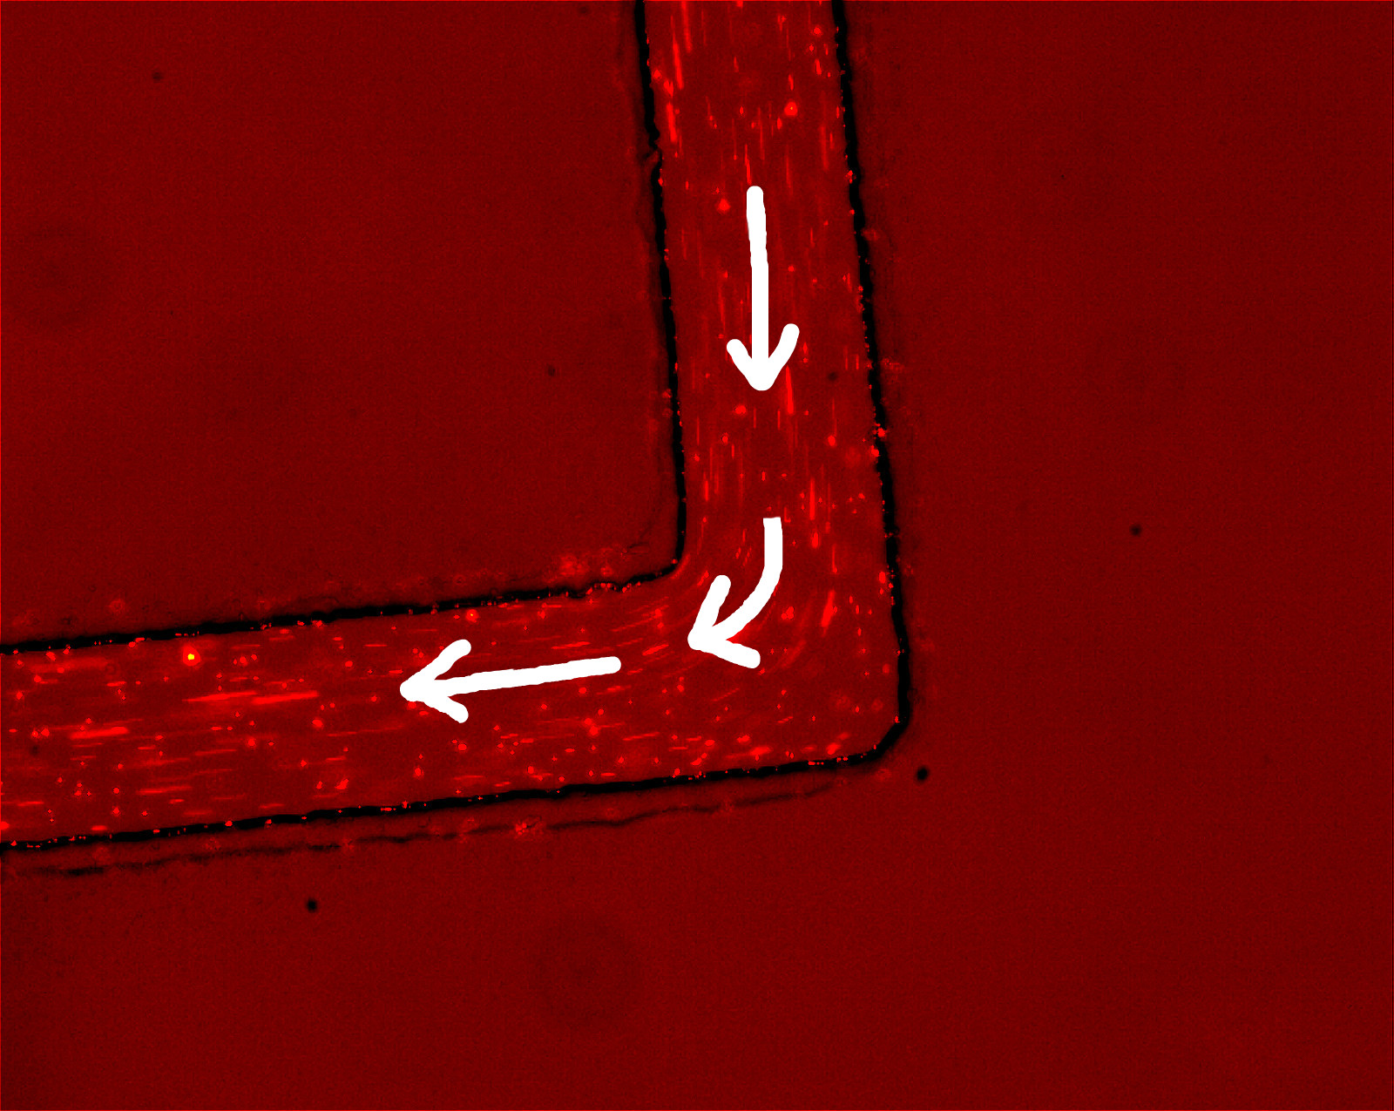

Figure 6 A sketch of the bead motion passing through a bend

**Conclusion**

This experiment reveals that the velocity of the fluid in the center is higher than that of the fluid on the sides, and with the width of the channel gradually increasing or decreasing, the velocity of the fluid inversely decreases or increases. Furthermore, the velocity of the fluid reduces after going through a sharp angle bend.

**References and Bibliography**

[1]: Bryan Keith, Eric Chung and Trevor Dell, “Introduction to Microfluidics”